Abdominal wall
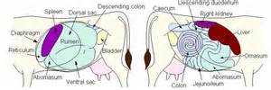

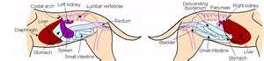
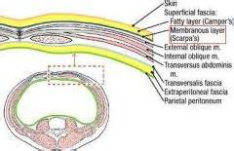

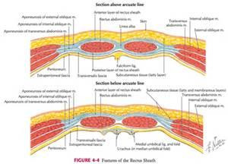

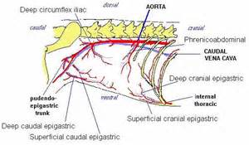

Surgical Judgment:
The last choice or the correct decision of the surgeon, which need great experiences, and these experiences can b estimated from.
- years of hard working in the field dealing with the case ,
- and from learning of the others and yours mistakes,
- as well as the academic literatures
For example doing the operation or not, using the antibiotics or such drugs, selection type of anesthesia or the site of operation.
- Is the surgery necessary? What would happen if the surgery was not performed? Removal of chip fracture from the carpus or imputation of the splint bone.
- If the case, well- equipped well-staffed hospital with specially qualified personal and have complication arise due to in adequate training and facilities.
- The economics, would the owner better to have the animal transported to a slaughterhouse, rather than having it undergo costly surgery with the chance of a long and expensive convalescence? Treat the animal with drugs or not if the withdrawal times of the drugs preclude the possibility of immediate slaughter and use for human consumption.
- The facilities are suitable or not for the operation in the field or in the dust- free operating theater, the post surgical infection.
- Whether the antibiotics are indicated, or whether post operative infection can be anticipated. Three determinant of an infection in a surgical site: host defence; physiological derangement; and bacterial contamination risk at surgery .control methods include aseptic surgical practices as well as identification of the high – risk patient, correction of systemic imbalances prior to surgery, and the proper use of prophylactic antibiotics.
- the correct dosage and amount of time of The antibiotics.the prophylactic antibiotics, administrated in the hope of preventing infectious complications, should be given preoperatively and at the latest, during surgery itself, to be of maximum benefits. Beyond 4 hours postsurgically, the administration of prophylactic antibiotics has little to no effect of the incidence of postoperative infection.
Factors affecting the surgical operation:
- Age.
- Fatty animal.
- Cardio vascular diseases.
- Respiratory diseases.
- Renal diseases.
- Pregnancy.
- Diabetes diseases.
- Breed and species.
Some important comments to the surgeon.
- Time of operation. Early morning for post operative car and observation.
- Checking the anatomy before the operation.
- Normal condition and behavior.
- Pre operative examination. For CBC, urinalysis, PCV, Total protein count, BUN, Creatinine, and analysis of peritoneal fluid. (Treatment from parasit and give electrolyte if necessary).
- Preparation pre operation.
- Post operative care.
- Anesthesia less than 10 weeks.

Types of surgical operation:
The surgical operation can be classified to three main types according to the incidence of contamination statues.
- Clean surgery is that in which the gastrointestinal, urinary, or respiratory tract is not entered. (Removal of the chip fracture of a carpal bone in arthrotomy operation).
- Clean- contaminated surgery is that in which the gastrointestinal, urinary, or respiratory tract is entered; however, there is no significant spillage of contaminated contents, such as with abomasopexy for displaced abomasums in the dairy cow.
- Contaminated –dirty surgery is that in which gross spillage of contaminated body contents or acute inflammation occurs, of fresh traumatic wound.

Each surgical operation may be one of the following depend on the priority and the aim of the surgical operation
- Elective surgery ,in that you have enough time for the operation to prepare everything that involved in the operation which include the surgeon and his team, the patient and site of operation ,then the instruments and the operating theater. For example fixation the fractures.
- Emergency surgery in that there are no time to prepare for the operation for example treachestomy or treacheotomy.
Surgical preparation
Generally, to deal with any medical or surgical case, there are three main factors you must pass thru, to reach and deal with the case as shown in the diagram below
1. The surgical or medical doctor
Diagnostic triangular

3. The patient 2. The owner
- The doctor can never dealing with the patient unless he passing thru the owner and he must satisfied the owner, to reach the proper key for the diagnosis and later find the suitable treatment
- The owner not always telling the truth for that,
If he knows that he is know that’s good
But if he know that he is not know, that’s not good
Or maybe he not knows that he not knows, and here is the problem.
Any surgical interference need to prepare the following
- The doctors and his team
Triangular Surgical

3. The instrument and the theater 2.The patient and the site operation
- Preoperative preparation:
- Preparation of the surgical doctor and his team
- Preparation of the instruments and the theater
- Preparation of the patient and the surgical site

Preoperative evaluation of the patient for
- Packed cell volume (PCV), total protein measurement, a complete blood count (CBC).
- Fluid replacement should be performed
- Postponed the operation if the laboratory parameter or the animal physical condition is abnormal.
- Internal and external parasite must be treated before operation.
- Urinalysis to evaluate the presence of ketones body and blood urea nitrogen (BUN) and keratinize.
- Analysis of peritoneal fluid, chemistry panel is performed.
- Radiography ,sonar,lbroscopy,and endoscopy
- Preparation During the surgical operation
- Prepare everything which related to the operation.
- Oxygen and anesthetics agents
- Fluid and blood transfusion
- Monitoring all the physiological parameter
- Post surgical care
- Daily checking the site of operation
- Systemic antibiotics
- Pain killer
- Remove the suture materials 7-10 days post operation
- Checking the normal body function.
Labarotomy Exploratory, abdominal approach (Laboratory incision)
- Midline incision. For c.s operation or nephratomy or gastratomy
- Para midline incision left or right after the midline and before the rectus abdominal muscle, or at the rectus abdominal muscles, or after the rectus abdominal muscle. For unilateral overactomy or nephrectomy or nephratomy
- Flank region upper and lower transverse or oblique incision
- Inguinal opening. For chriptorechdism or migrated testes.
- From the lateral at the 2 oclock of the inner wall of the vagina.for cystic ovary or unilateral overectomy.
Indication.
- Surgical operation for the internal organ.
- Diagnosis.
Complication.
- Inflammation of the sites of operation.
- Peritonitis.
- Hernia.
- Local infection.
- Odema.
- Internal bleeding.
- abscess

